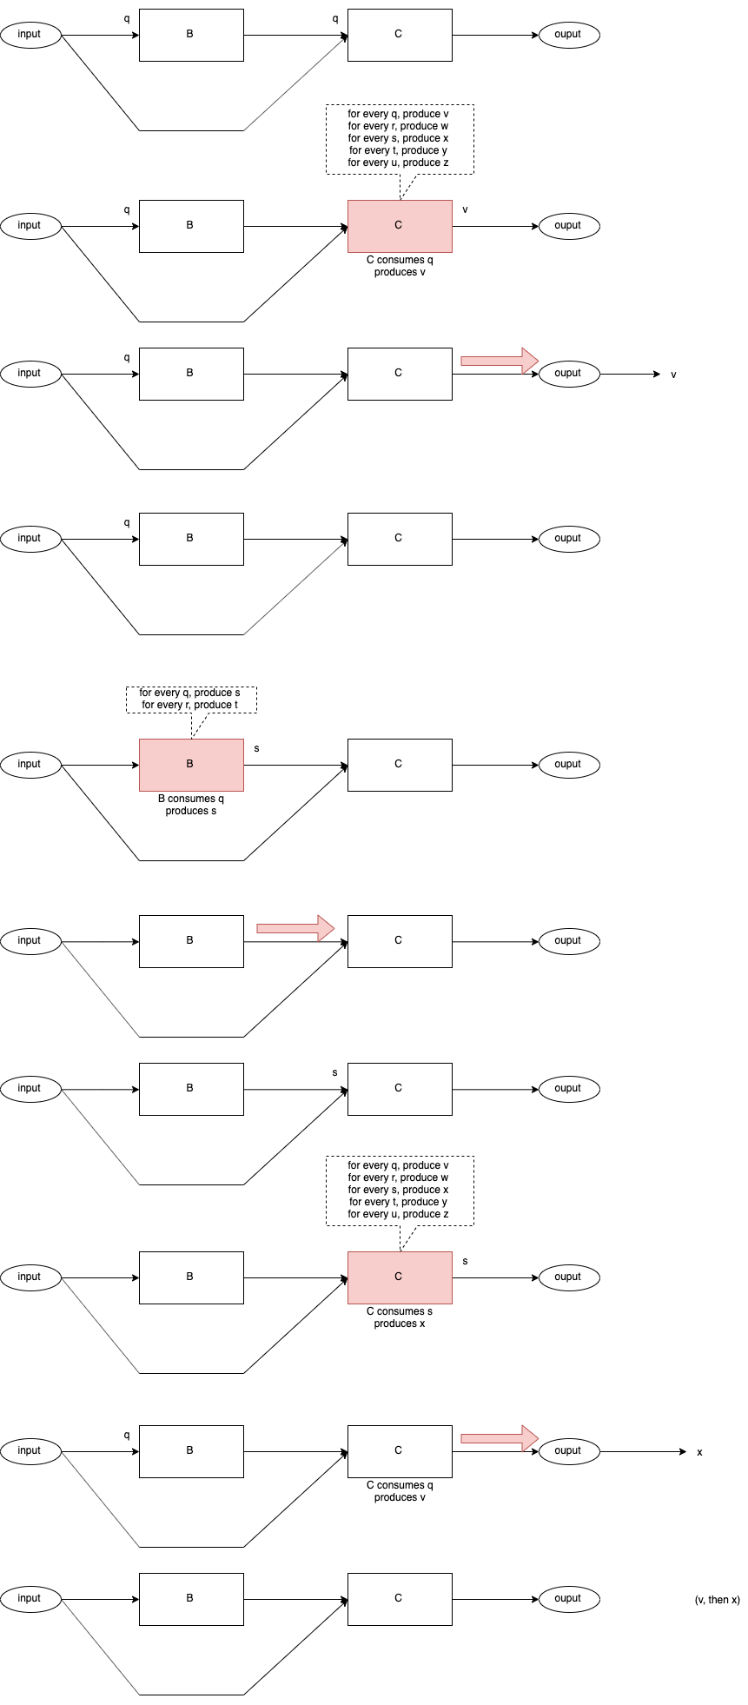
Fig. <$n:figure:AsyncControlFlowCB> Control Flow CB

